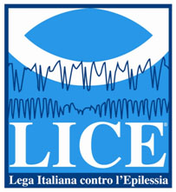
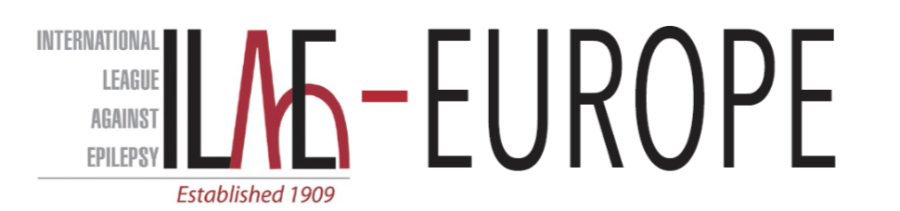

9th International Residential Course on Drug Resistant Epilepsies

Bambino Gesù Children’s Hospital – IRCCS, Rome – Italy
With the endorsement of
International League against Epilepsy
ILAE Europe
Lega Italiana Contro l’Epilessia

Tagliacozzo (AQ), Italy
4-10 September 2022

PROGRAMME AND FACULTY

Sunday 4th of September
16.00-18.00 | Arrival
18.30-19.30 | Welcome and introduction to the Course | Organizing Committee and local authorities

Monday 5th of September
 |  | Chair: M. Bialer – M. Walker
08.30-09.30 | L1 | Drug resistant epilepsy: concept and biological basis |  |  | E. Palma
09.30-10.30 | L2 | Old & New Antiepileptic Drugs (AEDs) and their Clinically-Relevant Drug Interaction |  |  | M. Bialer
10.30-11.00 | Coffee Break
11.00-12.45 | WG1 | P. Tinuper | E. Gardella | M. Bialer
13.00-14.30 | Lunch
 |  | Chair: M. Bialer – M. Walker
14.30-15.15 | L3 | Personalized medicine, where we are: is still far from the real world? |  |  | N. Specchio
15.15-16.15 | L4 | Gene therapy for epilepsy: how far is? |  |  | M. Walker
16.15-16.45 | Coffee Break
16.45-19.15 | Plenary Case presentation | Chair: P. Tinuper – F. Vigevano

Tuesday 6th September
 |  | Chair: F. Vigevano – E. Gardella
08.30-09.30 | L1 | New AEDs in the pipeline: What is next after fenfluramine and cenobamate |  |  | M. Bialer
09.30-10.30 | L2 | Critical interpretation of clinical trials |  |  | E. Perucca (remote)
10.30-11.00 | Coffee Break
11.00-12.45 | WG1 | M. Bialer | P. Tinuper | E. Gardella
13.00-14.00 | Lunch
 |  | Chair: H. Cross – E. Gardella
14.00 -14.45 | L3 | Genetic panels and molecular tests |  |  | M. Trivisano
14.45 – 15.30 | L5 | How to deal with Developmental and epileptic encephalopathies |  |  | H. Cross
15.30 – 16.00 | Coffee Break
16.00 – 16.45 |  | Cellular and molecular biomarkers in drug resistant epilepsies |  |  | E. Aronica
16.45 – 18.00 | WG2 | E. Gardella | M. Bialer | P. Tinuper
18.00 – 19.30 | Plenary Case presentation | Chair: H. Cross - N. Specchio

Wednesday 7th of September
 |  | Chair: L. de Palma – P. Tinuper
08.30 – 09.30 | L1 | Structural abnormalities in Developmental and Epileptic encephalopathies |  |  | R. Guerrini
09.30 – 10.15 | L2 | Video-EEG in early onset severe epilepsies |  |  | L. Fusco
10.15 – 10.45 | Coffee Break
 |  | Chair: M. Trivisano – F. Vigevano
10.45 – 11.30 | L3 | From genetic testing to the phenotype |  |  | E. Gardella
11.30 – 12.15 | L4 | Developmental and Epileptic encephalopathies in adults |  |  | F. Bisulli
12.15 – 13.30 | WG1 | M. Trivisano/R. Nabbout | L. de Palma | E. Trinka
13.30 – 14.30 | Lunch

Thursday 8th of September
 |  | Chair: P. Curatolo – E. Trinka
08.30-09.30 | L2 | Can we predict drug resistant Epilepsies? |  |  | S. Zuberi
09.30 – 10.30 | L1 | Dravet Syndrome and new treatment perspectives |  |  | L. Lagae
10.30 – 11.15 | L3 | Treatable metabolic epilepsies |  |  | B. Plecko
11.15 – 11.45 | Coffee Break
11.45 – 13.15 | WG1 | E. Trinka | M. Trivisano/ R. Nabbout | L. de Palma
13.15 – 14.15 | Lunch
 |  | Chair: N. Specchio – L. Lagae
14.15 – 14.45 | L4 | Epilepsy Genetic Initiative (CURE Foundation) |  |  | TBA
14.45 – 15.45 | L5 | Status Epilepticus in epileptic patients |  |  | E. Trinka
15.45 – 16.45 | L6 | Rescue medications in epilepsy |  |  | F. Vigevano
16.45 – 17.15 | Coffee Break
17.15 – 19.00 | Plenary Case presentation | Chair: S. Zuberi – R. Nabbout

Friday 9th of September
 |  | Chair: TBA – TBA
 |  | SURGICAL REMEDIABLE EPILEPSIES
08.30 – 09.30 | L2 | Management of drug resistant epilepsies in children: is duration of epilepsy a matter? |  |  | A. Arzimanoglou
09.30 – 10.30 | L1 | Indication and outcome of epilepsy surgery |  |  | L. Tassi
10.30 – 10.45 | Coffee Break
10.45 – 11.30 | L3 | TBA |  |  | TBA
11.30 – 13.00 | WG1 | L. de Palma | E. Trinka | M. Trivisano/R. Nabbout
13.00 – 14.30 | Lunch
 |  | Chair: A. de Benedictis – TBA
14.30 – 15.30 | L4 | TSC drug treatment and surgical approach |  |  | F. Jansen
15.30 – 16.30 | L5 | Epilepsy surgery in genetic epilepsies |  |  | K. Braun
16.30 – 17.15 | L6 | Neuromodulation |  |  | C.E. Marras
17.15 – 17.30 | Coffee Break
17.30 – 19.00 | Plenary Case presentation | Chair: C.E. Marras – F. Jansen

Saturday 10th of September
 |  | Chair: F. Vigevano – N. Specchio
 |  | Novel diagnostic tools for novel therapies
09.00 – 09.45 | L1 | Developmental and epileptic encephalitis: how comorbidities influence the outcome | R. Nabbout
09.45 – 10.30 | L2 | Autism in Developmental and epileptic encephalopathies | S. Auvin
10.30 – 11.15 |  | Case presentation
11.15 – 11.30 |  | Coffee Break
 |  | Short pills for emerging treatments
11.30 – 11.45 | L3 | Sponsored talk | TBA
11.45 – 12.00 | L4 | Sponsored talk | TBA
12.00 – 12.45 | L5 | The case of TPP1 replacement treatment | N. Specchio
12.45 – 13.30 |  | Grand Round and Competition | All
13.30 – 14.30 | Lunch
End of course

Tutors and topics
E. Gardella | Differential diagnosis in children
M. Bialer | Drug interactions
F. Bisulli | Differential diagnosis in adults
L. de Palma | Seizure semiology and diagnostic value of video-EEG
TBA (Trinka ?) | Practical management in adult patients with SE
M. Trivisano/ R. Nabbout | Genetic epilepsies

- @epitagliacozzo
- www.facebook.com/epilepsy.tagliacozzo
www.epilepsytagliacozzo.com info@epilepsytagliacozzo.com

